ASSIGNMENT - 1

**HOME AUTOMATION**

# NAME : KEERTHIKA J

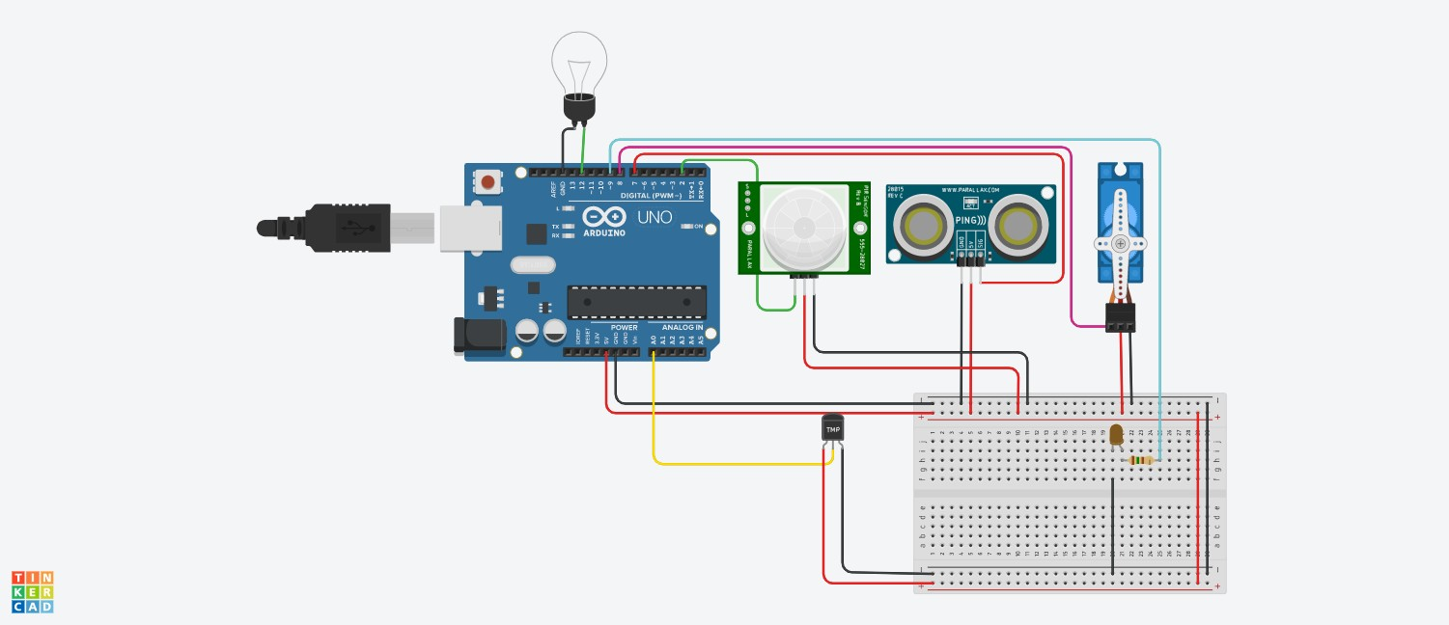ROLL NO: 113119UG03048

CIRCIUT :

# CODE :

#include <Servo.h> int dist = 0;

long readUltrasonicDistance(int triggerPin, int echoPin)

{

pinMode(triggerPin, OUTPUT); / Clear the trigger digitalWrite(triggerPin, LOW); delayMicroseconds(2);

/ Sets the trigger pin to HIGH state for 10 microseconds digitalWrite(triggerPin, HIGH);

delayMicroseconds(10); digitalWrite(triggerPin, LOW); pinMode(echoPin, INPUT);

/ Reads the echo pin, and returns the sound wave travel time in microseconds

return pulseIn(echoPin, HIGH);

}

Servo servo_8; void setup()

{

servo_8.attach(8, 500, 2500); pinMode(2, INPUT); pinMode(12, OUTPUT); pinMode(A0, INPUT); pinMode(9, OUTPUT);

}

void loop()

{

dist = 0.01723 * readUltrasonicDistance(7, 7); if (dist <= 100) {

servo_8.write(90);

delay(1000); / Wait for 1000 millisecond(s)

} else { servo_8.write(0);

delay(1000); / Wait for 1000 millisecond(s)

}

if (digitalRead(2) == 1) { digitalWrite(12, HIGH);

delay(1000); / Wait for 1000 millisecond(s)

} else {

digitalWrite(12, LOW);

delay(1000); / Wait for 1000 millisecond(s)

}

if (analogRead(A0) > 200) { digitalWrite(9, HIGH);

delay(1000); / Wait for 1000 millisecond(s)

} else {

digitalWrite(9, LOW);

delay(1000); / Wait for 1000 millisecond(s)

}

}

TINKERCAD LINK :

https://www.tinkercad.com/things/7lV68hGUW5V-neat-tumelo-luulia/editel?sharecode=I8Q0lPz33Wtv2RUkavarscqH8ZiVImQJyo46hjCYMrQ